EXAM REGISTRATION SYSTEM:

Use Case Diagram:
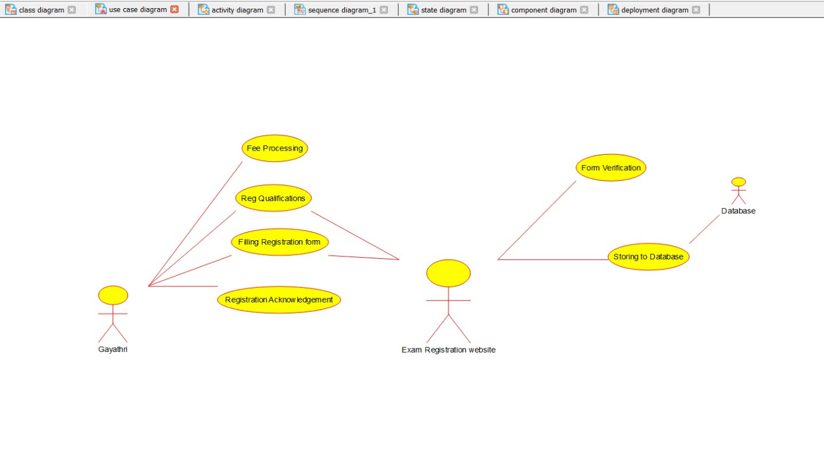
Activity Diagram:
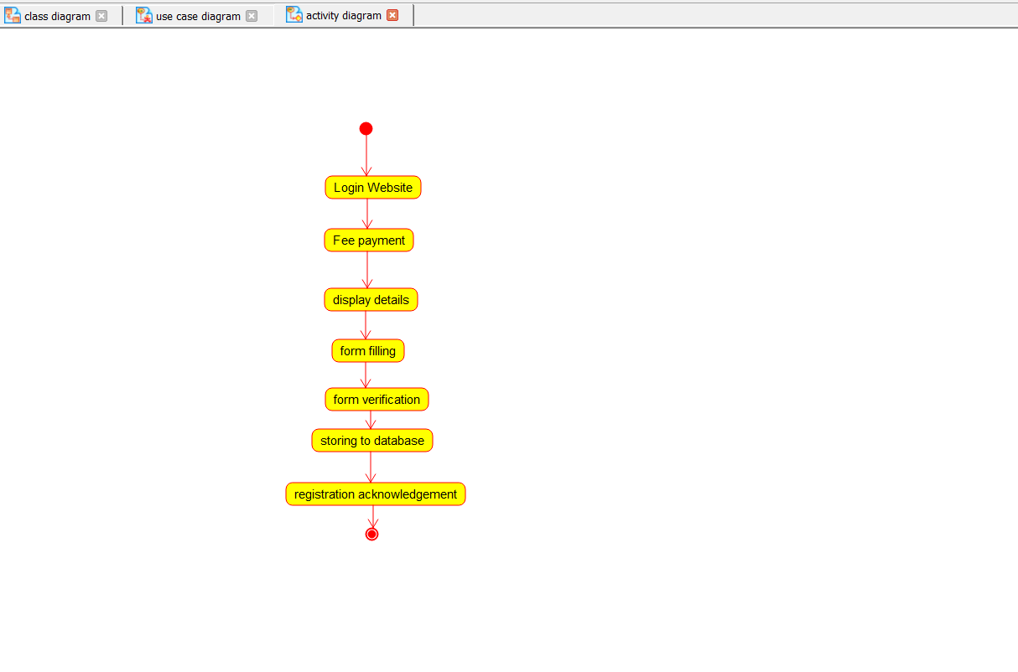

State Diagram:
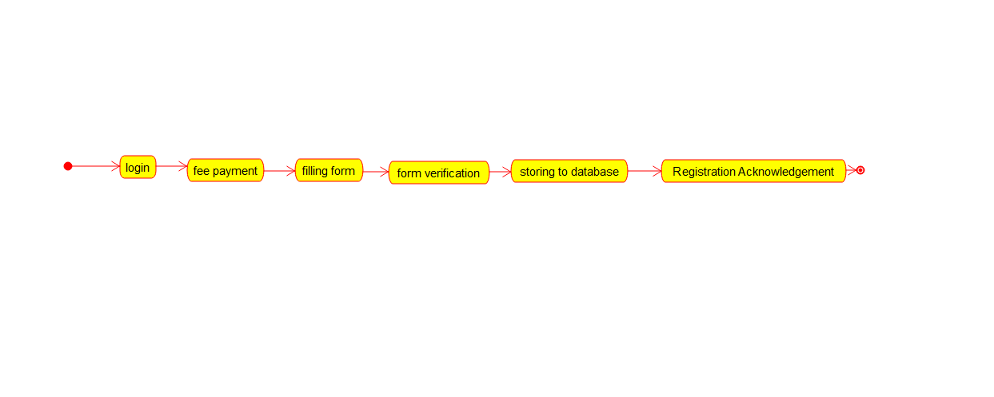

Class Diagram:
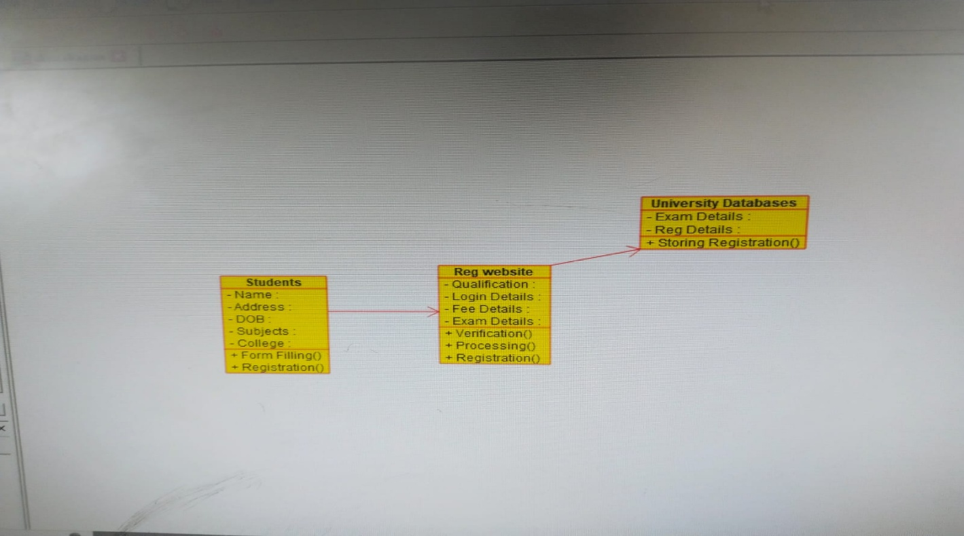

Sequence Diagram:
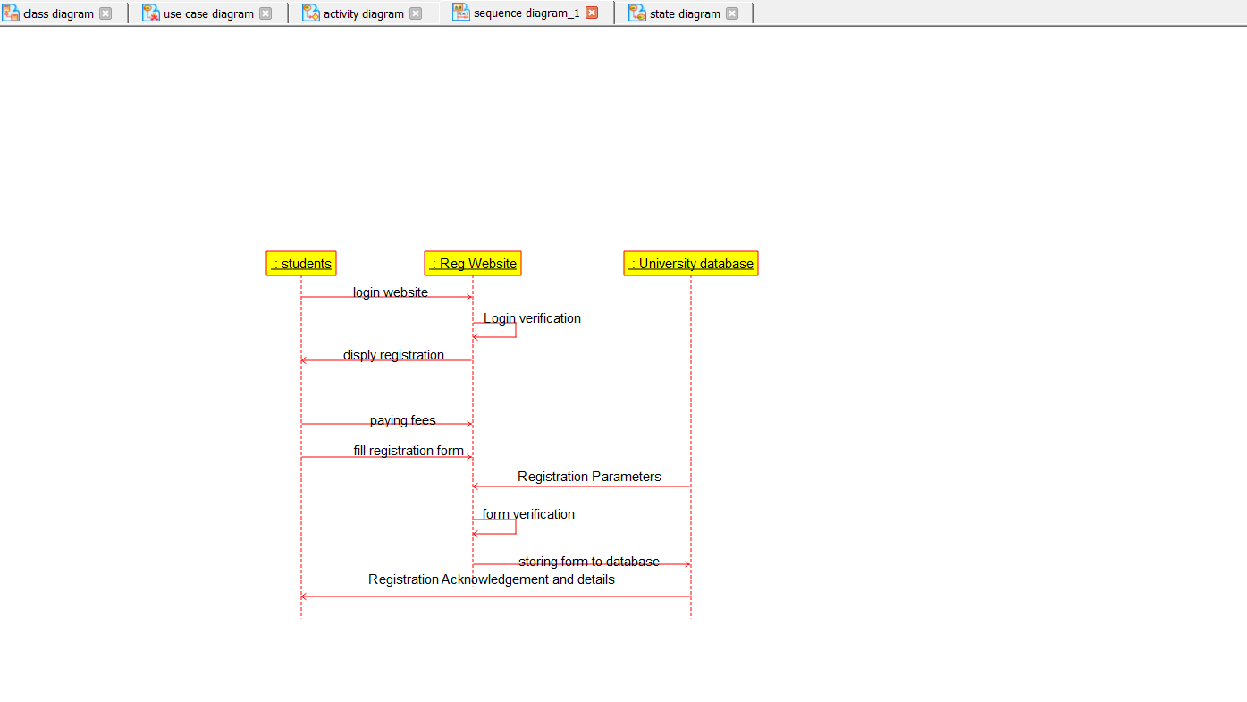

Deployment Diagram:
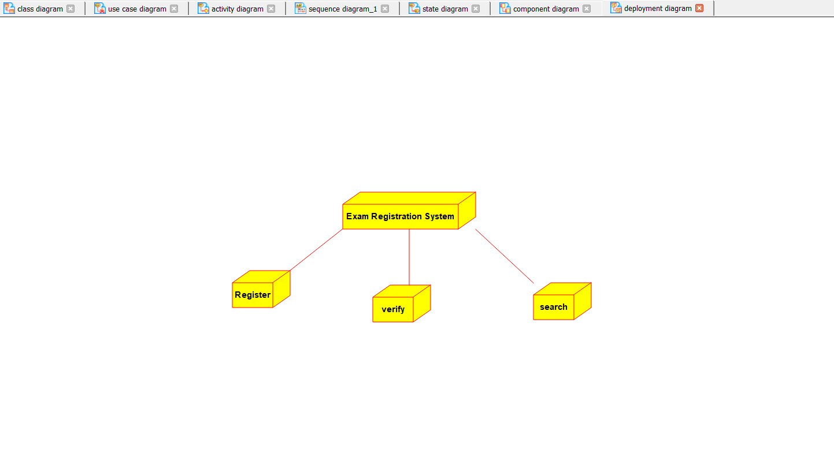
Component Diagram:
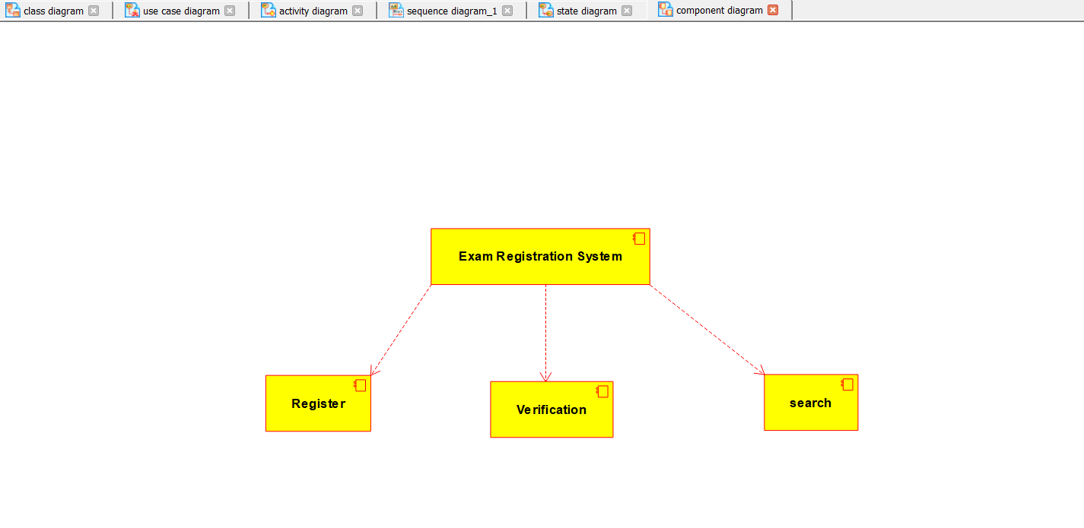

Reg_Website

#include "Reg_Website.h"

// Constructors/Destructors
//

Reg_Website::Reg_Website () {
}

Reg_Website::~Reg_Website () { }
students
#include "students.h"

// Constructors/Destructors
//

students::students () {
}

students::~students () { }
University_database
#include "University_database.h"

// Constructors/Destructors
//

University_database::University_database () {
}

University_database::~University_database () { }

